**Australian Islamic College 2020**

**ATAR Chemistry Units 3 and 4**

**Task 8B (Weighting: 2%)**

**Organic Chemistry Test 2**

Test Time: 25 minutes

Please do not turn this page until instructed to do so.

|  |  |
| --- | --- |
| **First Name** | **Surname** |
| **ANSWERS** |  |

|  |
| --- |
| **Teacher** |
|  |

|  |  |
| --- | --- |
| **Mark / 28** | **Percentage** |
|  |  |

Equipment allowed: Pens, pencils, erasers, whiteout, correction tape, rulers and non-programmable calculators permitted by the Schools Curriculum and Standards Authority.

**Special conditions**:

2 marks will be deducted for failing to write your full name on this test paper.

**Teacher help**: Your teacher can only help you during your test in one situation.

If you believe there is a mistake in a question show your teacher and your teacher will tell you if there is a mistake in the question and if appropriate, how to fix that mistake.

**Spelling of Science words** must be correct. Unless otherwise indicated, science words with more than one letter wrong (wrong letter and/or wrong place) will be marked wrong. The spelling of IUPAC names must be exactly correct.

Unless otherwise stated, **equations** must be written balanced and with correct state symbols or they will be marked wrong.

Questions must be answered in this booklet.

Total marks: 28

**PART ONE: MULTIPLE CHOICE QUESTIONS (3 MARKS)**

**Circle the correct answer on this page.**

Questions 1 and 2 refer to the four molecules shown below.

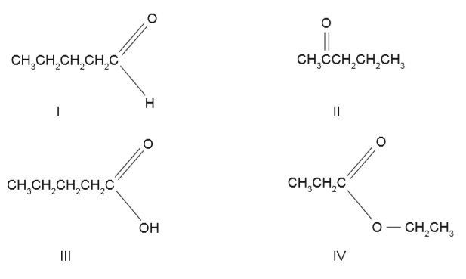

1. Which one of the alcohols below can be oxidised to produce Compound II above?
   1. CH3CH2CH2CH2CH2OH
   2. **CH3CH2CH2CHOHCH3**
   3. CH3CH2CHOHCH2CH3
   4. CH3C(OH)(CH3)CH2CH3
2. Which one of the compounds I to IV above will react with an alcohol in the presence of an acid?
   1. I
   2. II
   3. **III**
   4. IV
3. What is the IUPAC name of the product of the reaction between bromine water and CH3CH2CHCHCH3?
   1. 2,3-bromopentane
   2. 2,3-dibromopent-2-ene
   3. 3,4-dibromopentane
   4. **2,3-dibromopentane**

**PART TWO: SHORT ANSWER QUESTIONS (25 MARKS)**

1. Draw structural formulae of the product/s of the reaction between the following two molecules. Show all atoms in the product/s.

(2 marks)

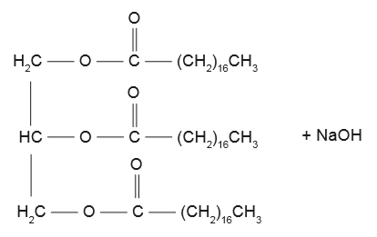

Answer/s:

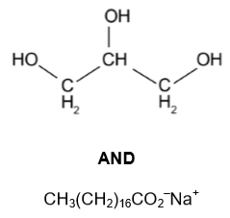

**Marker – 1 mark per answer. Structural or semi-structural formula OK. All atoms must be shown. Bond angles do not have to be correct. No half marks.**

1. Three different organic compounds were each tested with two reagents:

* Acidified sodium permanganate solution and
* Acidified propanoic acid

Each organic compound has a molecular formula containing four carbon atoms, one oxygen atom and a number of hydrogen atoms.

The observations made are summarised in the following table.

|  |  |  |
| --- | --- | --- |
| **Unknown Organic Compound** | **Reagent Added** | |
| **Acidified Sodium Permanganate Solution** | **Acidified Propanoic Acid** |
| **1** | No observable change | Fruity smell |
| **2** | Purple solution decolourises | No observable change |
| **3** | No observable change | No observable change |

1. Complete the table below, identifying the:

* Functional group responsible for the observations made
* Name of the unknown organic compound.

(6 marks)

|  |  |  |
| --- | --- | --- |
| **Unknown Organic Compound** | **Functional Group** | **IUPAC Name of the Unknown Organic Compound** |
| **1** | **Alcohol / Hydroxyl / Hydroxy** | **Methylpropan-2-ol**  **(accept 2-methylpropan-2-ol)** |
| **2** | **Aldehyde** | **Butanal or Methylpropanal**  **(accept 2-methylpropanal)** |
| **3** | **Ketone** | **Butanone (accept butan-2-one)** |

1. Give the name and draw the structural formula of the organic product of the reactions of Compound 1 and Compound 2. Include all atoms in your structural formula.
   1. Organic Compound 1 with the acidified propanoic acid.

(2 marks)

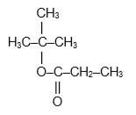

**Dimethylethyl propanoate**

**1 mark for structure, 1 mark for name. Condensed structural formula is OK but all atoms must be shown. No part marks.**

* 1. Organic Compound 2 with the acidified sodium permanganate solution.

(2 marks)

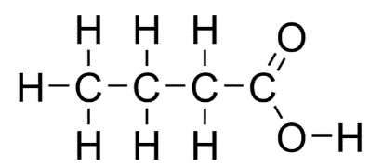

**Butanoic acid**

OR

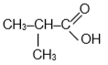

**Methylpropanoic acid (or 2-methylpropanoic acid)**

**1 mark for structure, 1 mark for name. Condensed structural formula is OK but all atoms must be shown. No part marks.**

**Answer must correspond to the answer to Q 2(a).**

**No follow-on marks.**

* 1. The following diagram represents a reaction pathway for the synthesis of Compound Q from pent-2-ene.

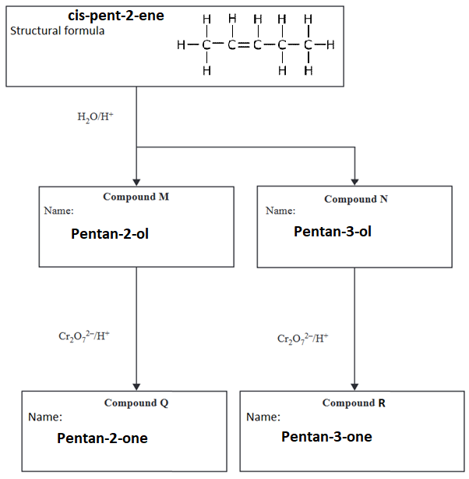

1. Draw the structural formula for cis-pent-2-ene in the box provided. Show all atoms.

(1 mark)

1. Two structural isomers are possible when cis-pent-2-ene is hydrolysed at a high temperature in the presence of an acid catalyst. Compounds M and N are formed. Give the IUPAC names of Compounds M and N in the boxes provided.

(2 marks)

1. When Compounds M and N are reacted with acidified dichromate ions, Cr2O72−, Compounds Q and R are formed. Name Compounds Q and R in the boxes provided.

(2 marks)

1. Ethanol is reacted with excess acidified potassium dichromate.
   1. Write oxidation and reduction half reactions and an overall reaction for this. Show all atoms. State symbols are not required.

(3 marks)

**CH3CH2OH + H2O 🡪 CH3COOH + 4H+ + 4e-**

**Cr2O72- + 14H+ + 6e- 🡪 2Cr3+ + 7H2O**

**3CH3CH2OH + 2Cr2O72- + 16H+ 🡪 3CH3COOH + 4Cr3+ + 11H2O**

* 1. Describe the colour change that occurs when this reaction occurs.

(1 mark)

**From orange to deep green (answer must include ‘deep’)**

* 1. The organic product of the reaction in part (a) above is divided into two portions.
     1. The first portion is reacted with propan-2-ol in the presence of a sulfuric acid catalyst. Name the product/s of this reaction.

(2 marks)

**Methylethyl ethanoate (accept 1-methylethyl ethanoate) (1)**

**Water (1)**

* + 1. The second portion is reacted with ethanamine in an acidified high-temperature environment. Draw the semi-structural (condensed) formulae of the product/s of this reaction. Show all atoms.

(2 marks)

**CH3CONHCH2CH3 (1)**

**H2O (1)**

**Structural formulae are OK too. All atoms must be shown. No part marks.**